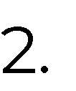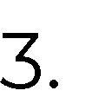





χ



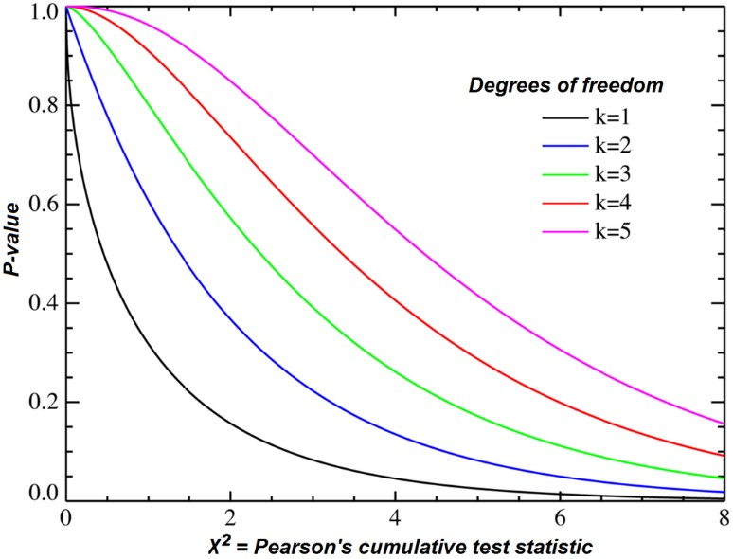

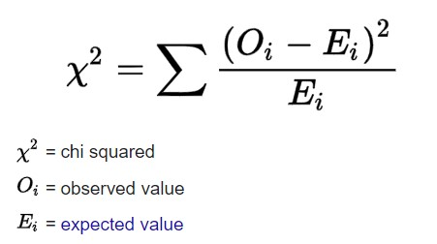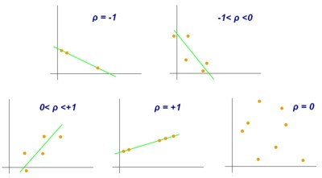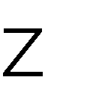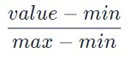

**z**

**=**

**(**

**x**

**–**

**μ)**

**/**

**σ**



Normalized value of attribute

=

**(**

**v**

**i**

**/ 1**

**0**

**j**

**)**



|  |
| --- |
| **Chi-square Test:**  **def** chi2test_with_x_y(): table = [ x,y ] stat, p, dof, expected = chi2_contingency(table) prob = 0.95 critical = chi2.ppf(prob, dof) if abs(stat) >= critical:  print("Dependent (reject H0)") else:  print("Independent (fail to reject H0)") print(str(expected))    **Pearson Coefficient:**  **def** pearsoncoef_with_x_y(): corr, _ = pearsonr(x, y) str=""  str+='Pearsons correlation: %.3f' % corr if(corr<0):  str+="\nNegative correlation exists" if(corr>0):  str+="\nPositive correlation exists" |

|  |
| --- |
| if(corr==0): str+="\nNo correlation exists" print(str)    **Covariance:**  **def** covariance_with_x_y():  cov_mat = np.stack((x, y), axis = 0) print(str(cov_mat)) cov_mat = np.stack((x, y), axis = 1) print(str(cov_mat))    **Normalization:**  **1.Min-Max:**  **def** min_max_norm_x():  x_min_max_scaled = x.copy() x_min_max_scaled = (x_min_max_scaled[5] - x_min_max_scaled[0]) / (x_min_ma x_scaled[5] - x_min_max_scaled[0]) plt.scatter(x_min_max_scaled, x_min_max_scaled) plt.show() print(str(x_min_max_scaled))    **2.Z-score:**  **def** z_score_norm_x():  x_z_scaled = np.array(x) x_z_scaled = (x_z_scaled[0] - x_z_scaled[3]) / x_z_scaled.std() plt.scatter(x_z_scaled, x_z_scaled) plt.show() print(str(x_z_scaled))    **3.Decimal Scaling:**  **def** dec_scale_norm_x(): p = x[5]  q = len(str(abs(p))) x_des_scaled = x[5]/10**q  plt.scatter(x_des_scaled, x_des_scaled) plt.show() print(str(x_des_scaled)) |



